Elementary Techniques

This section uses the file <button.ntl> to introduce several elementary techniques of working with the NeatTools graphical user interface (GUI). Subsequent Techniques sections will introduce more advanced methods (see Intermediate Techniques and Advanced Techniques). The simple procedures shown in these sections demonstrate how to edit and modify NeatTools programs.

Marquee selection
- Open <button.ntl> and enable the Edit Mode (ED). Select the Switch and LED modules by placing the mouse cursor above and to the left of the Switch, then left clicking and dragging the cursor below and to the right of the LED. (A single module is selected by simply left clicking on it so that sizing handles appear, as described below.) The screen should appear as below.

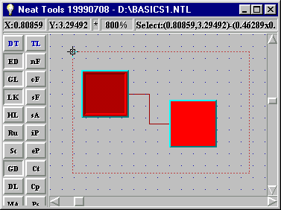

- As you release the mouse button, small squares called sizing handles, which appear like theatre marquee lights, surround the selected modules (see below). Clicking anywhere on the desktop background deselects the modules.
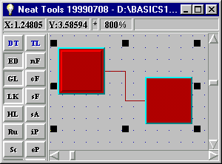

- There are several simple ways to simultaneously manipulate the modules once they are selected:
- Drag both modules anywhere on the desktop by left clicking on either one and dragging.
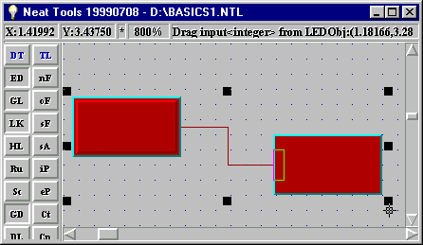
- Squeeze or stretch both modules by left clicking on one of the handles and dragging in the vertical or horizontal direction. As shown below, both modules were stretched by clicking on one of the right handles and dragging.

- Pressing the "Delete" key deletes both modules.

Copying modules
- Copy a module by left clicking on it with the "Ctrl" key held down and then dragging the copied module to a new location.

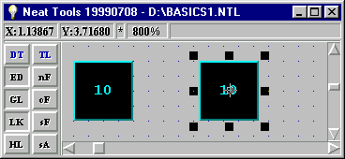
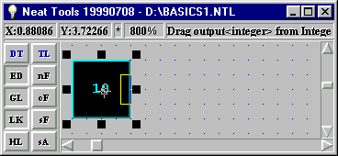

Zooming
- Alter the overall size of the visible area of the NeatTools desktop by left-clicking any of five buttons ("/2"; "-"; "1"; "+"; "x2") on the bottom of the Desktop Toolbar (DT). For example, the /2 button zooms out 2-fold so that objects appear smaller and the x2 button zooms in 2-fold so that objects appear larger.

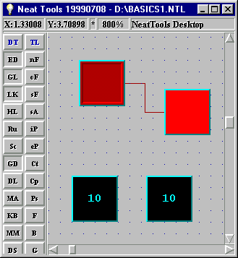
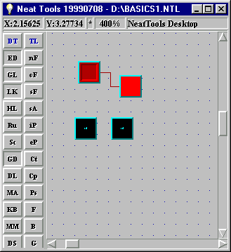

- It is generally advisable to use a screen size that is a multiple of 100% (it is 800% and 400% above, as indicated in the Status Bar) to make snapping to the grid simpler. For further editing in this and subsequent sections, it is usually preferable to return to the originally chosen zoom level (typically 200% for simple programs) so that modules newly dragged from toolboxes will have the standard size like other modules that were not resized.

- To reduce the size of the entire NeatTools desktop so that it encompasses only selected modules, select the Switch and LED modules and press "Ctrl-F9".
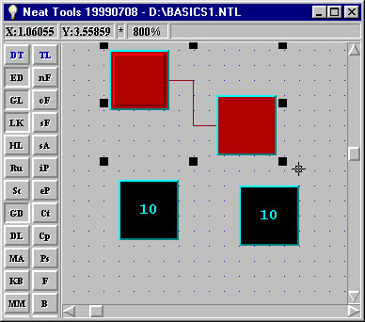
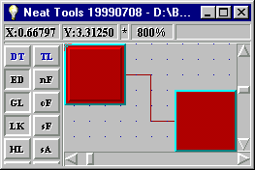

Protected Mode
- Pressing "Ctrl-F7" allows you to toggle back and forth between the "protected mode" and the "active editing mode". In protected mode, you cannot inadvertently alter the program.

